COAL Lab 06 Assignment:

# Name: Owais Ali Khan

# Section: 3-F

# Roll no: 21K-3298

Question # 01:

Include Irvine32.inc

.data

msg byte "Generating 20 random numbers between 0 and 990:", 0

.code

main PROC

call Clrscr

call Randomize

mov edx, offset msg

call WriteString

call Crlf

mov dh, 1 ; row 1

mov dl, 0

mov ecx, 20

L1:

mov eax, 990

call RandomRange

call GotoXY

call writeDec

add dh, 1

add dl, 2

mov eax, 50

call Delay

loop L1

exit

main ENDP

END main

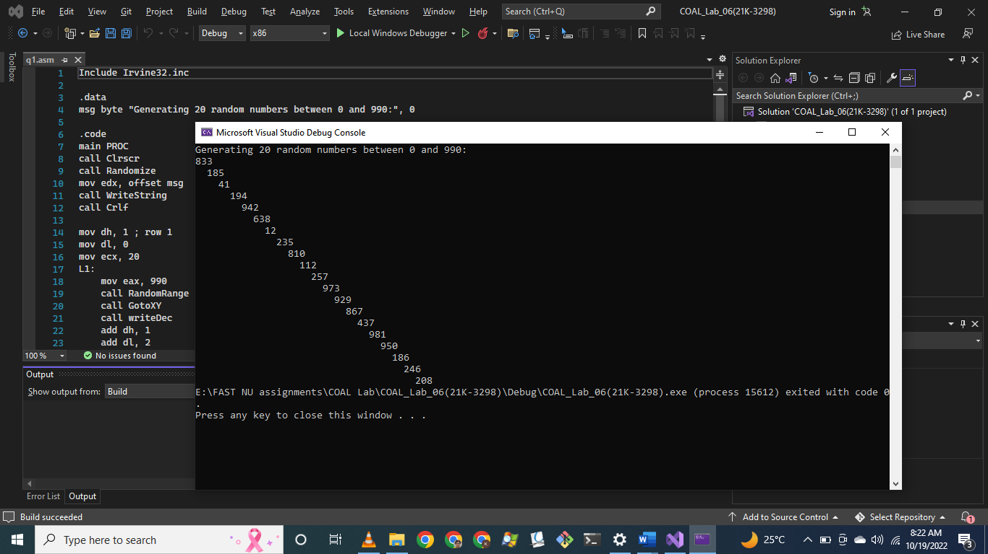

Question # 02:

Include Irvine32.inc

.data

char BYTE '*'

timingDelay DWORD 100

loopCount DWORD 100

.code

main PROC

call Randomize

mov eax, 0

mov edx, 0

call GetMaxXY

and eax, 000000FFh

mov dh, al

;call writeDec

;call Crlf

;movzx eax, dl

;call writeDec

sub dh, 11

sub dl, 1

mov ecx, loopCount

L1:

push dx

movzx eax, dh

call RandomRange

mov dh, al

movzx eax, dl

call RandomRange

mov dl, al

call GotoXY

movzx eax, char

call writeChar

mov eax, timingDelay

call Delay

pop dx

loop L1

exit

main ENDP

END main

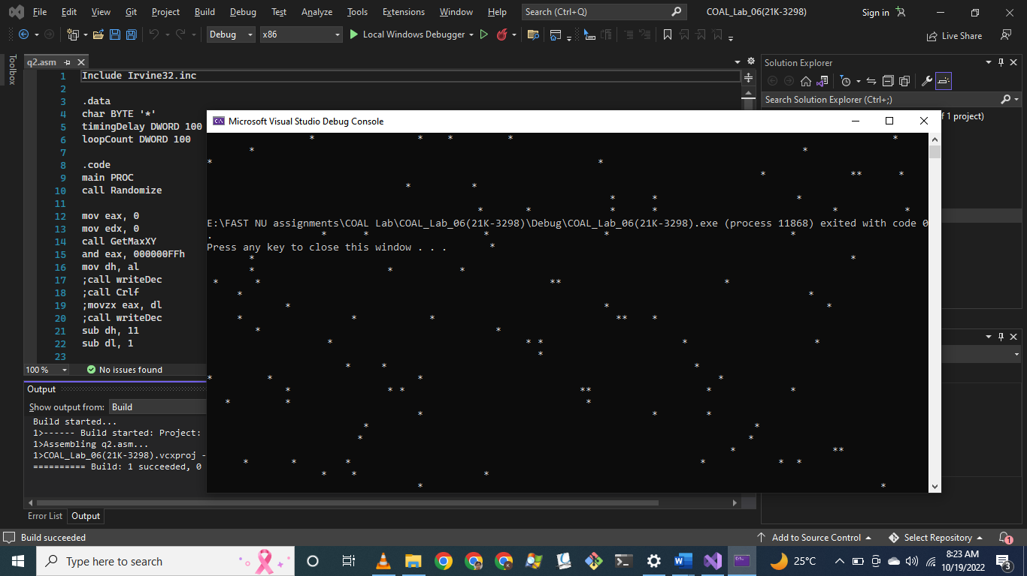

Question # 03:

Include Irvine32.inc

.data

msg_1 BYTE "Generating 10 random unsigned numbers (0 to 4,294,967,294):", 0

msg_2 BYTE "Generating 10 random signed numbers: (-50 to +49)", 0

space DWORD " "

startRange = -50

endRange = +49

.code

main PROC

call Randomize

mov edx, OFFSET msg_1

call WriteString

call Crlf

mov ecx, 10

L1:

call Random32

call WriteDec

mov eax, space

call WriteChar

loop L1

call Crlf

call Crlf

mov edx, OFFSET msg_2

call WriteString

call Crlf

mov eax, startRange

neg eax

add eax, endRange

mov ecx, 10

L2:

push eax

call RandomRange

add eax, startRange

call WriteInt

mov eax, space

call WriteChar

pop eax

loop L2

exit

main ENDP

END main

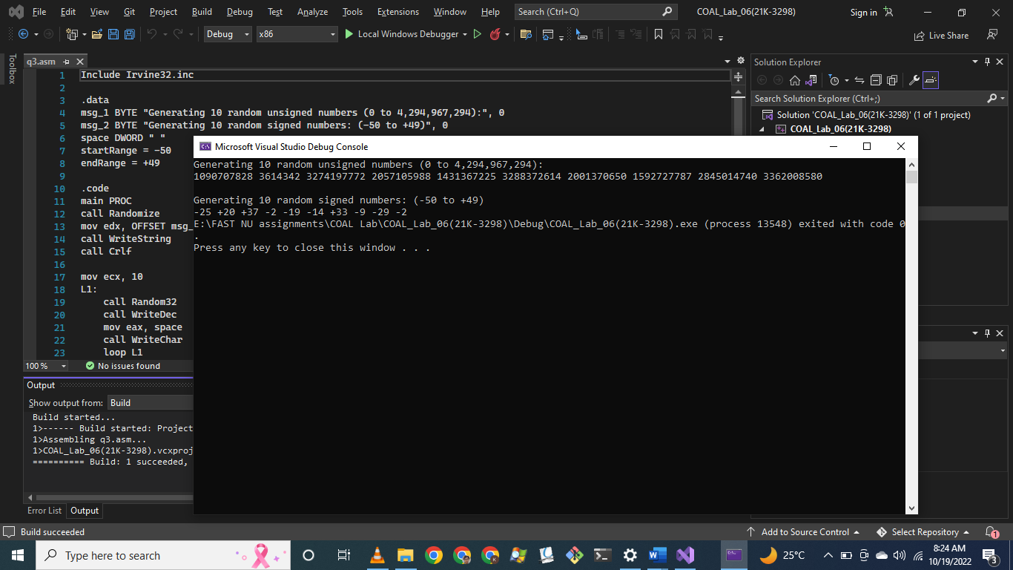

Question # 04:

Include Irvine32.inc

.data

bufferSize = 100

buffer BYTE bufferSize DUP(?)

filename BYTE "MyFile.txt", 0

fileHandle HANDLE ?

prompt BYTE "Enter string: ", 0

.code

main PROC

mov edx, OFFSET filename

call CreateOutputFile

mov fileHandle, eax

mov edx, OFFSET prompt

call WriteString

mov edx, OFFSET buffer

mov ecx, bufferSize

call ReadString

mov eax, fileHandle

mov edx, OFFSET buffer

mov ecx, bufferSize

call WriteToFile

call CloseFile

exit

main ENDP

END main

